Annemount Health and Safety Risk Assessment
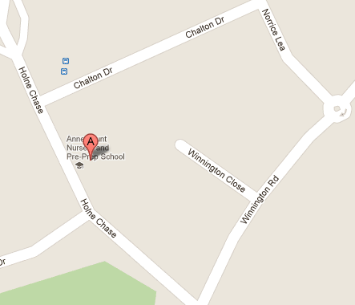

Location: Date: Completed by:
Morning walk Reception, Year One and Two 15/07/24 Aiden Griffin (H&S Officer)

Assessment review to be each term.
Next assessment review:- Dec 2024
What are the hazards? | Who might be harmed and how? | What are you already doing? | What further action is necessary? | Action by who? | Action by when?
Missing children | Children and staff missing from the group. | Upon departing for the morning walk, the class register must be taken, completed in full and left in each classroom.  - Any absent children must be noted on a post-it and taken with a class list on the walk. The lead teachers must have full knowledge of those attending the walk and any absentees.  - A second note must be made on how many children are attending the walk and handed to a designated person within the school building. | Should a child appear to be missing, senior teacher to return to the last point the child was and search the area. Headcount of all other children to ensure no one else is missing. Missing child policy to be followed. | All teachers and adults | On-Going
Uneven Pavement | Children and staff tripping and falling. | Class teacher to lead the group noticing any particular hazards on the pathway. | Discussion with the class prior to leaving about potential hazards and being aware of their surroundings and the uneven pavement. | Reception, Year One and Two staff attending the morning walk. | On-Going
Road/Pavements and movement of traffic | Children walking into the road and being knocked by a car. | Teachers to be spread throughout the group. Teachers to be vigilant of the groups movements as they move around the suburb. | Discussion with the class prior to leaving about potential hazards and being aware of their surroundings and their safety as they walk. | Reception, Year One and Two staff attending the morning walk. | On-Going
Crossing roads and movement of traffic. | Children and staff. Collisions with motor vehicles. | Class teacher to stop the group upon crossing a road. Children to be informed prior to crossing the road of traffic awareness. Teacher to stand in the centre of the road informing oncoming traffic of the crossing by placing their hand up and palm out in a stopping motion. Children to cross when indicated by the class teacher and wait by the nearest tree or lamppost indicated by the teacher. The whole group cross as the class teacher remains in the centre of the road stopping oncoming traffic. | To continue to inform children during class discussions and assemblies about road safety.  Continued reminders are made prior to leaving the building and going on a walk about road traffic awareness. | Reception, Year One and Two staff attending the morning walk. | On-Going
Passing driveways of homes and movement around concealed entrances. | Children and staff. Collisions with motor vehicles. | Class teacher approaches the driveway, leading the class past upon a clear inspection.  Should a driver be in a car and about the leave the class teacher will await the all clear by indicating to the driving the class is about to pass, or stop the group and wait for the driver to exit the driveway. | Class teacher to lead the way throughout the morning walk ensuring all driveways are clear and safe to pass.  Each adult present to continue to monitor. | Reception, Year One and Two staff attending the morning walk. | On-Going

